**3.wireless networking (music dance lights)**

**1.Preparation**

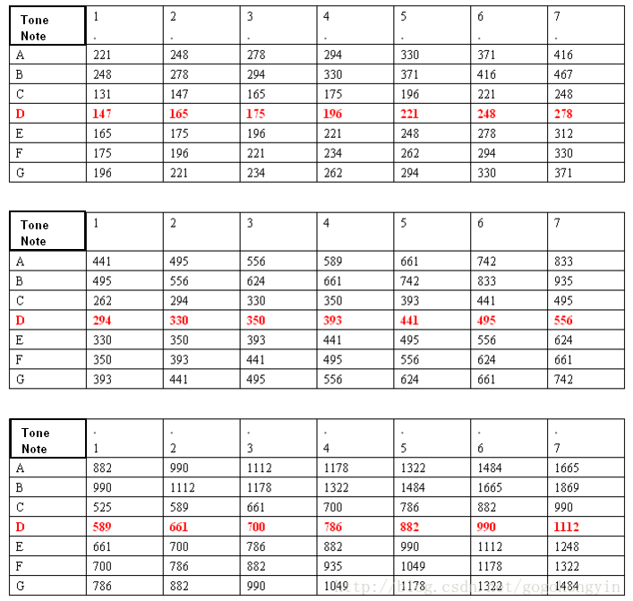

3-1 the table of Note

With the note table above, you also need to master the beat. The rule of the beat is that the single note is not underlined, that is one beat (1), the underline is half beat (1/2), and the two underlines are quarter beat. There are two bars at the back with a horizontal bar. And the two lines are two beats.

In this experiment, we used A segment of music.(For example)



3-2

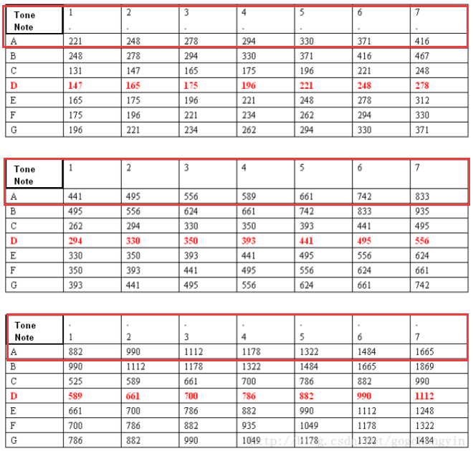

3-3

1. **Learning goals**

After starting multiple Hellobot cars, you can press “B” key to play music, and with the effect of flashing lights, you can press “B” key again to play music and dance with the effect of flashing lights.

**4.Download programming**

You need to make sure that the micro:bit development board is connected to the computer. Then you should click on the download in the lower left corner as shown in P 2-5 to download the program to micro:bit.

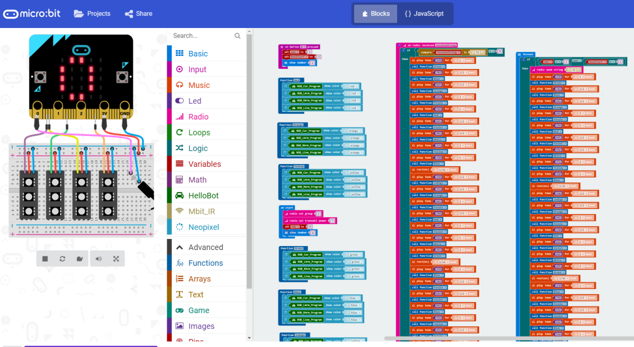

3-4

**5.Phenomenon**

You need to download code to all hellobot cars. After starting multiple Hellobot cars, you can press the “B” key of one of the cars, all the cars start to play music with some special effects of flashing lights.

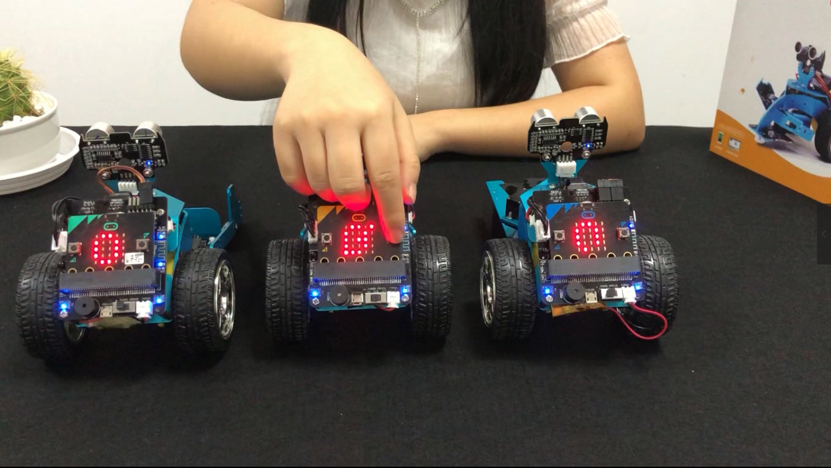

3-5

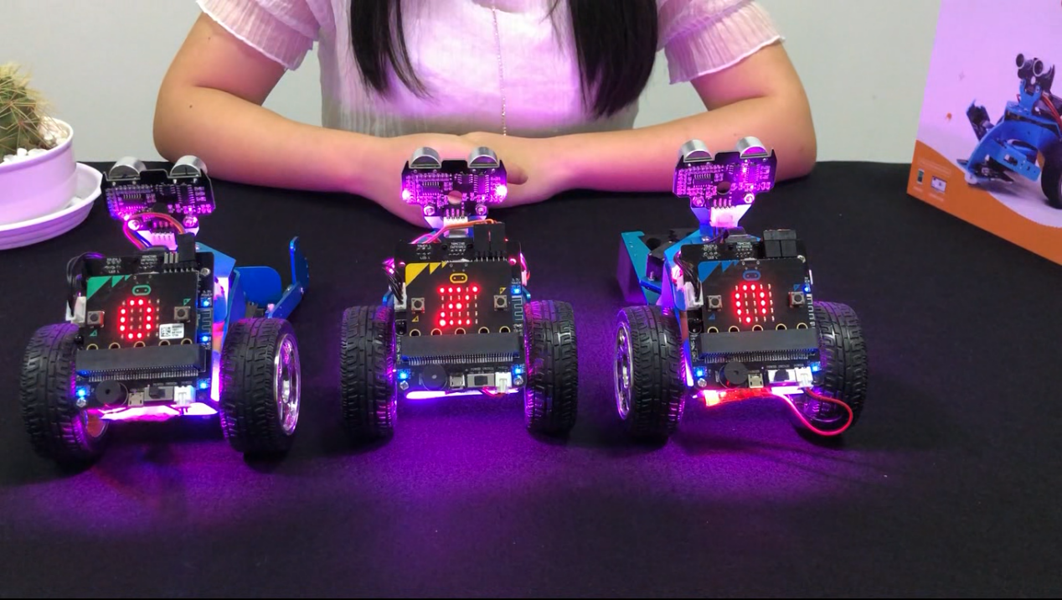

3-6